Gitlab Fundamentals: Afzaal Ahmad

Gitlab Overview

Gitlab Accounts

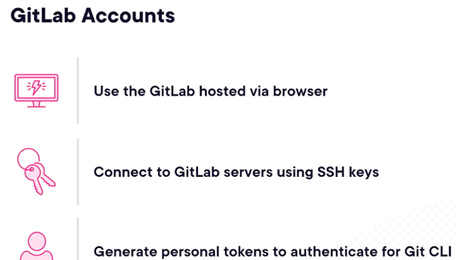

-Browser: can use username and password

-Desktop: SSH keys to connect to repo or personal access tokens (replacement for passwords)

CI/CD and AutoDevOps

AutoDevOps

-One click solution to add a pipeline

-CI/CD files takes precedence over ADO

git-lab-cl.yml

-Stages:

-Each stage can multiple jobs

Yaml Tutorial: TechWorld with Nana

<https://www.youtube.com/watch?v=1uFVr15xDGg>

YAML

-used for Docker, Ansible and Kubernetes

-serialization language (XML, JSON)

SL

-means that app written in different technologies, languages which have different data structure can transfer data to each other using standard format (most popular formats are YAML, JSON)

-changed to YAML Ain’t Markup Language

-.yaml/.yml

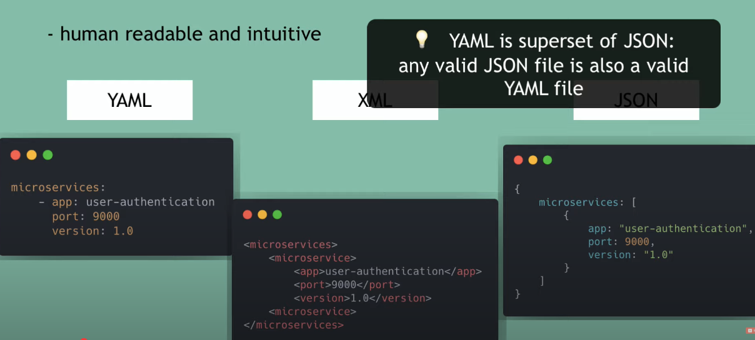

Boolean

-true/false, yes/no, on/off

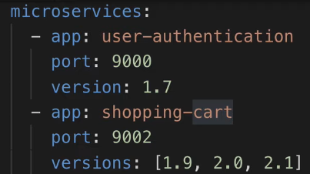

-Cant use - or [] for lists

multi

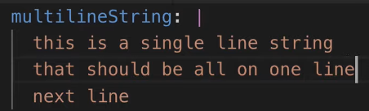

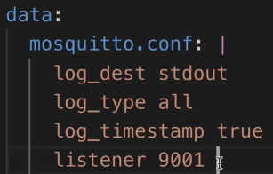

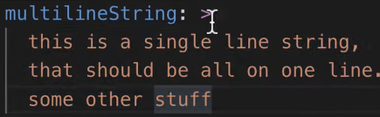

-makes it into a single line



-env variable

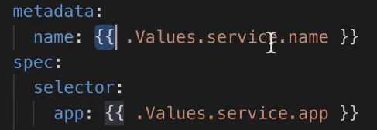

placeholder

**GitLab CI/CD Pipeline Tutorial for Beginners**

<https://www.youtube.com/watch?v=z7nLsJvEyMY>

Problem, during build and test stage the containers are destroyed.

Artifact

-is a config, that allows you to keep

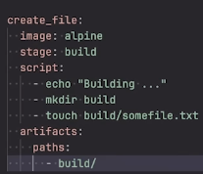

1. Find a Docker image that contains what you need
2. Run commands to build the project (installing dependencies and compiling)

**GitLab CI CD Tutorial for Beginners [Crash Course]**

<https://www.youtube.com/watch?v=qP8kir2GUgo>

CI/CD  
-Automatically and continuously testing, building, releasing code changes to deployment env

Gitlab

-advantage is your code is already on gitlab

Gitlab Runners

-Agents that run your CI/CD jobs (executing pipelines)

-are connected to Gitlab instance

Makefile

-special file containing shells commands

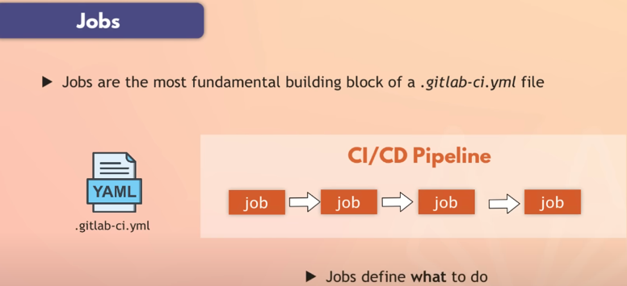

-A job is all those tasks

-define arbitrary names

-requires script clause (specify the commands to execute)



Instead of executing jobs diretly on OS, we use Docker